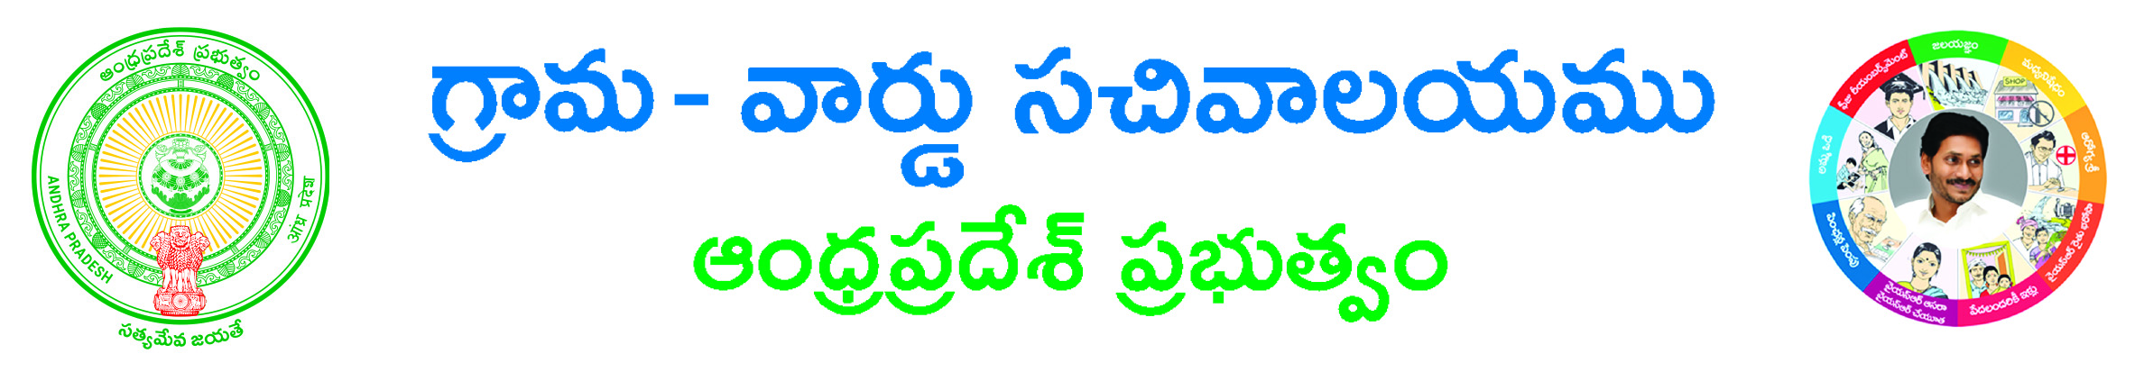

**Corrections in current adangal -Application Form**

**Adangal Details**

**District*:_______________________________ Mandal*:__________________________**

**Village / Ward *:______________________________ Survey No *:______________________________**

**Correction Type*: 🞏 Correction in Adangal Details 🞏 Correction in Khata Number**

**🞏Correction In Survey Number**

**Edit Fields in Correction in Adangal Details :**

**Land Nature: ________________________ Water Source : _________________________**

**Water Source Extent: _________________ Enjoyment Nature: _______________________**

**Pattadar Name: ______________________ Pattadar Father Name: ___________________**

**Occupant Name: ______________________ Occupant Father Name: __________________**

**Occupant Extent: _______________________ Water Source Extent: ____________________**

**Edit Fields in Correction in Khata Number:**

**Land Nature: ________________________ Water Source: _________________________**

**Water Source Extent: _________________ Khata No: ____________________________**

**Enjoyment Nature: ____________________ Pattadar Name: ______________________**

**Pattadar Father Name: ___________________ Occupant Name: ______________________**

**Occupant Father Name: __________________ Occupant Extent: _______________________**

**Edit Fields in Correction In Survey Number:**

**Survey No: ___________________________ Land Nature: ________________________**

**Water Source : _________________________ Water Source Extent: _________________**

**Enjoyment Nature: _______________________ Pattadar Name: ______________________**

**Pattadar Father Name: ___________________ Occupant Name: ______________________**

**Occupant Father Name: __________________ Occupant Extent: _______________________**

**Applicant Details :**

**AADHAR Card No: __________________________ Applicant ame*:_____________________**

**Father's/Mother's/Guardian's Name*: ______________________________________________**

**Gender*:🞏 Male 🞏 Female**

**Permanent Address:**

**State *: __________________________________ Door No: ________________________________________**

**District*:________________________________________ Mandal*:__________________________________**

**Village / Ward *:__________________________________ Pin code: __________________________________**

**Locality / Land Mark: __________________________ Mobile*: _______________________________**

**E-Mail : ______________________________ Delivery Type*: 🞏 Manual 🞏 Local post🞏 Non Local post**

**Documents List:**

**(NOTE: 1.Total size of Upload Document should not exceed 3 MB.2. All Upload Documents should be in PDF Format Only)**

1. **Application Form\***

**Applicant’s Signature**